Conditional Statements :-

1. Write a C program to find number is positive, negative or zero.

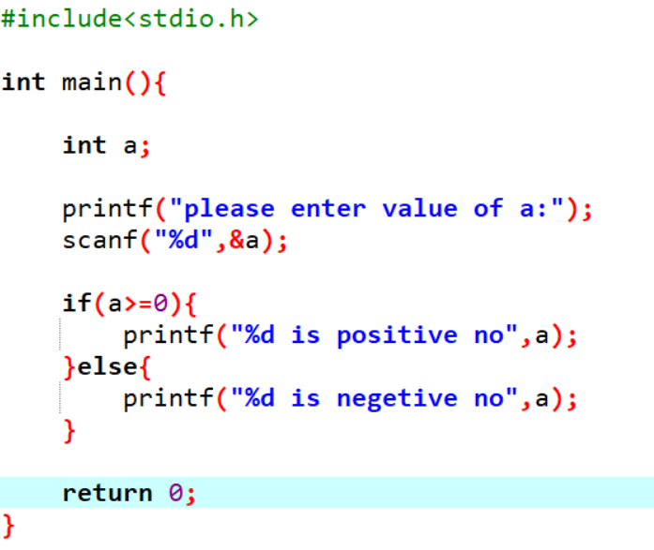

Output:-





2. Write a C program to find Grade from percentage. Here range is given below:

* 91 - 100    A
* 81 - <91    B
* 71 - <81    C
* 61 - <71    D
* 40 - <61    E
* <40            Failed

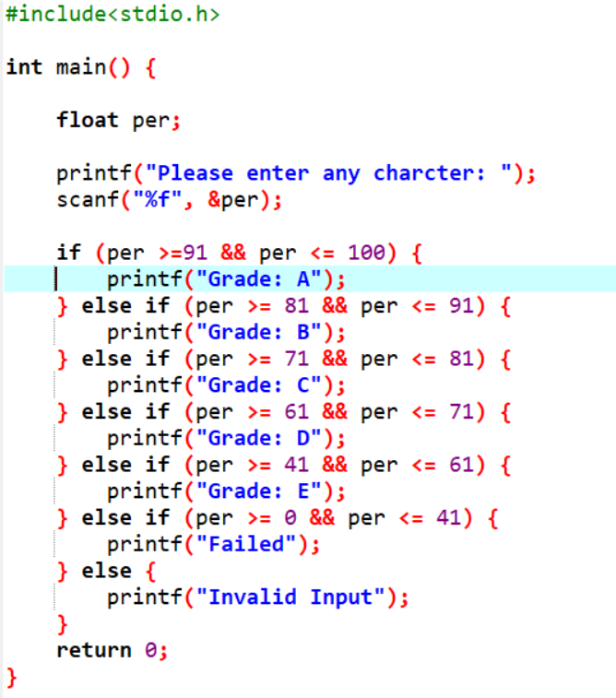

Output:-



3. Write a C program to find input is alphabet, number or special symbols.

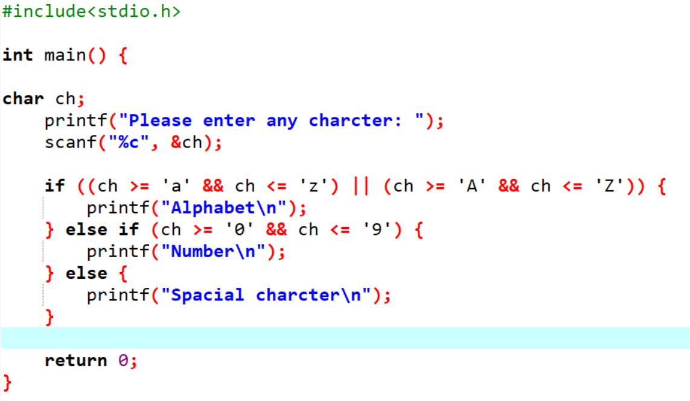

Output:-







4. Write a C program to compare two number.

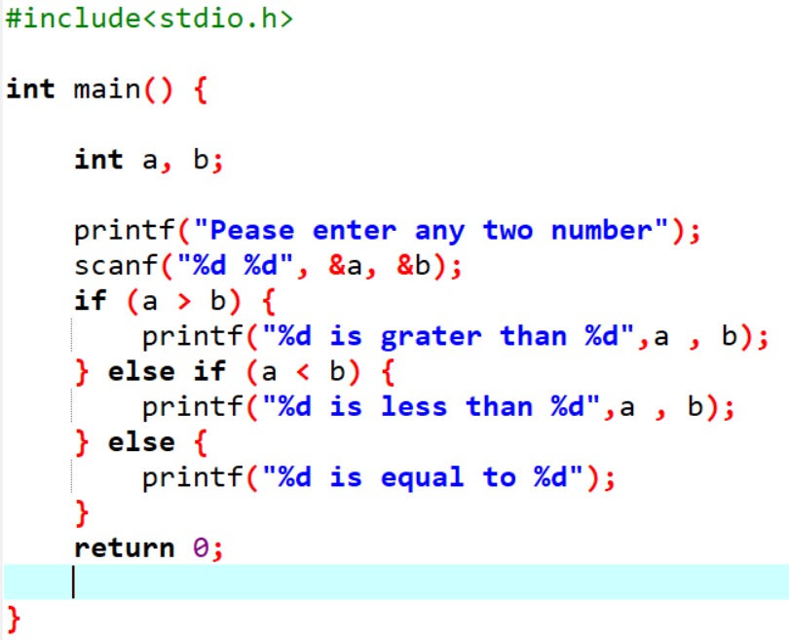

Output:-

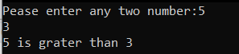

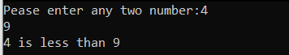

5. Write a C program to find leap year.

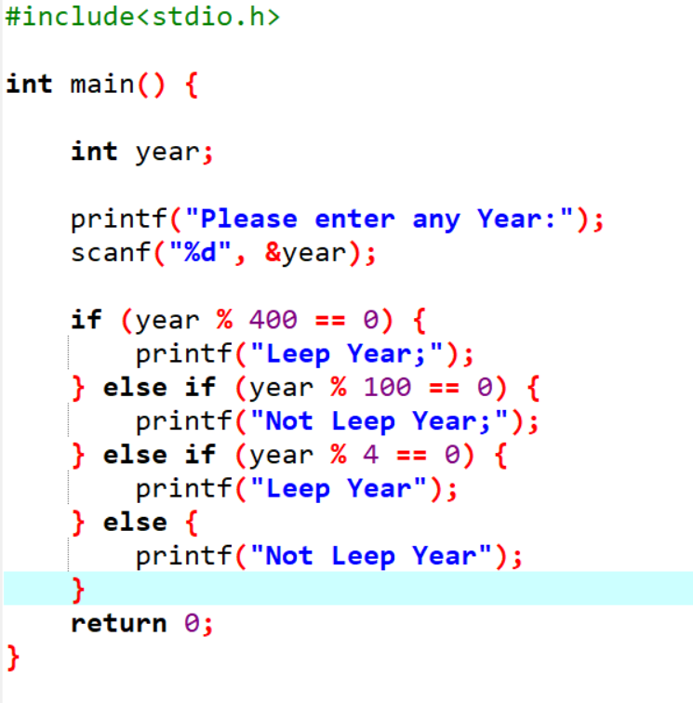

Output:-





6. Write a C program to input electricity unit charges and calculate total electricity bill according to the given condition : For first 50 units Rs. 0.50/unit

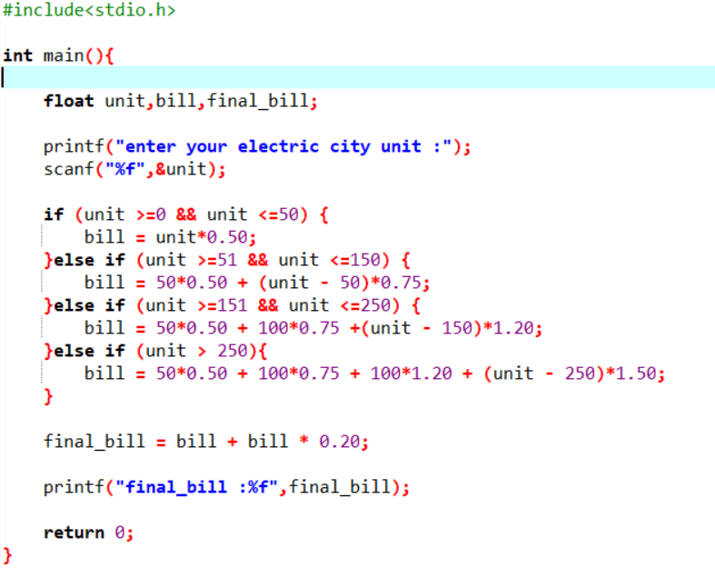  
For next 100 units Rs. 0.75/unit  
For next 100 units Rs. 1.20/unit  
For unit above 250 Rs. 1.50/unit  
An additional surcharge of 20% is added to the bill.

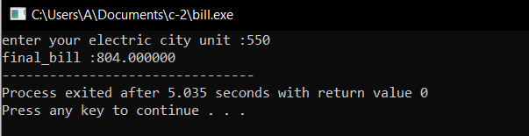

7. Write a C program that ask your gender and salary and give bonus according to following criteria:

* If you are male and your salary is less than 10000 than company will provide 2% bonus of your salary
* If you are female and your salary is less than 10000 than company will provide 3% bonus of your salary

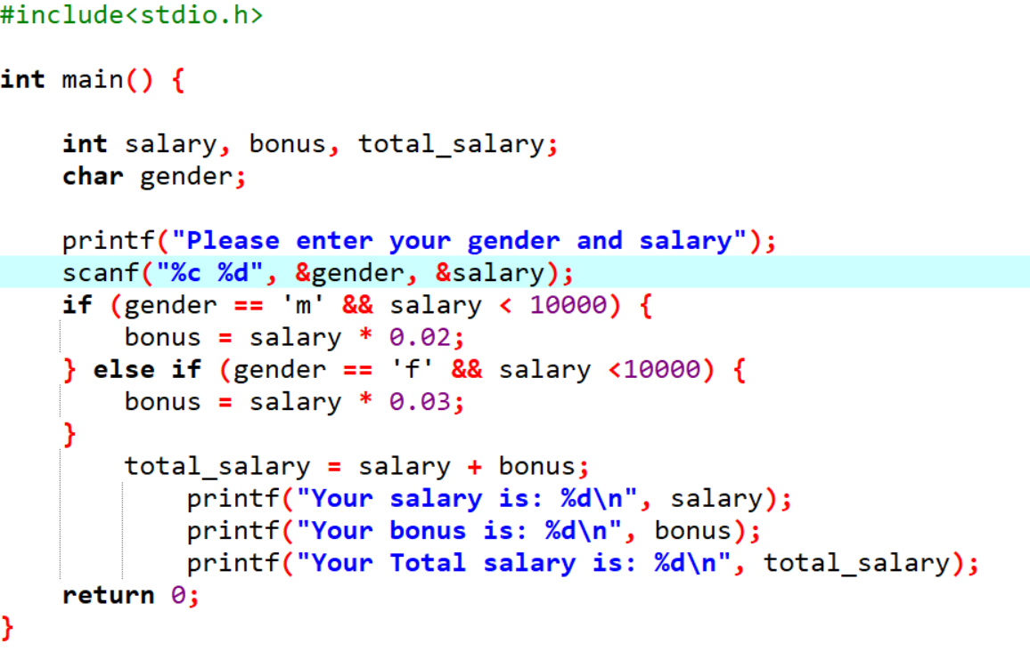

Output:-

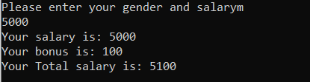



8. Write a C program to calculate tax from given image.

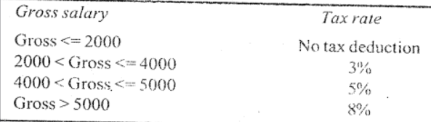

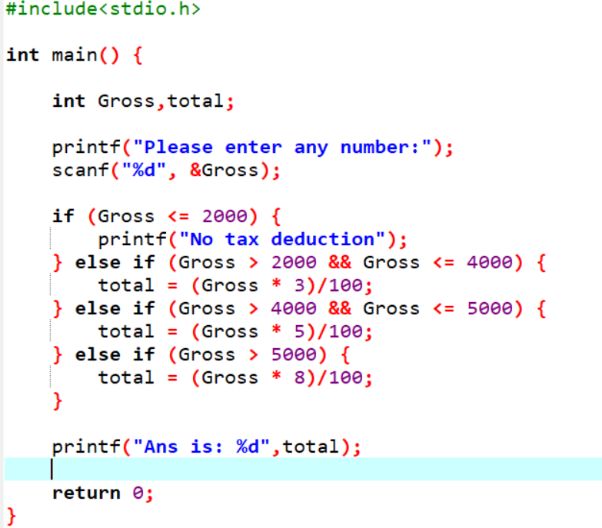

Output:-



9. Write a C program for calculate scholarship from given criteria:   
    Cast Criteria:

* Open: No Scholarship
* OBC: 25%
* SC: 50%
* ST: 100%

Grade Criteria:

Your grade must be same or above B to eligible for scholarship.

Grade:

A   (CGPA: 9+)

* B    (CGPA: 8.5+)
* C     (CGPA: 8+)
* D   (CGPA: 7.5+)

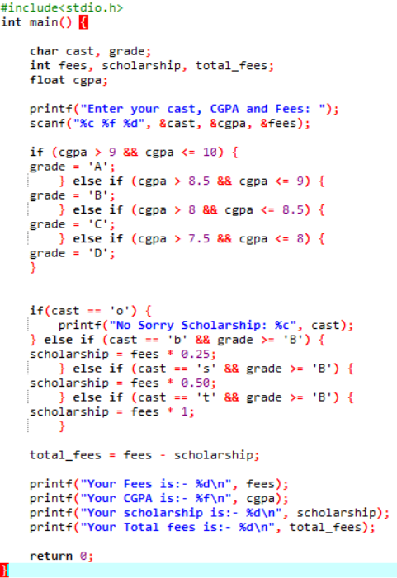

Output:-

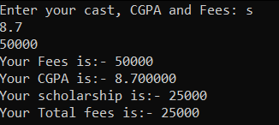

10. Write a C program for calculate your net income from given criteria:

* If your net income is below 10000 you have not to pay any tax.
* If your net income is below 15000 you have to pay 10% tax.
* 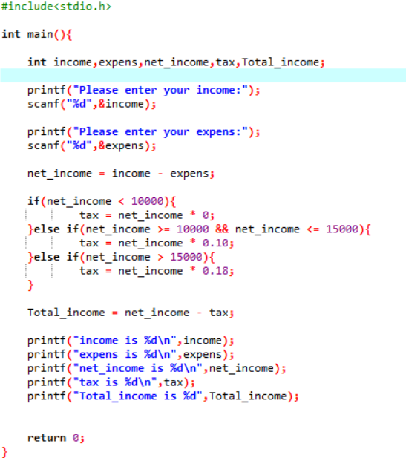f your net income is above 15000 you have to pay 18% tax.

Output:-

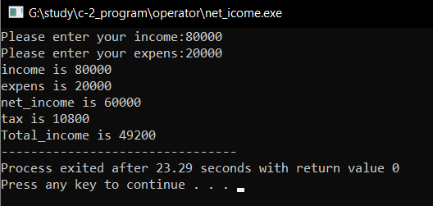

11. Write a C program to find out maximum from 3 numbers using nested if.

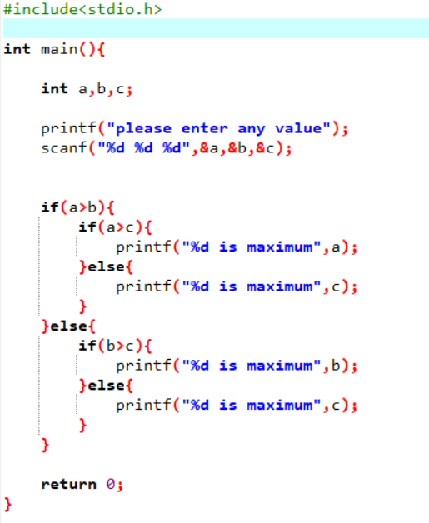

Output:-

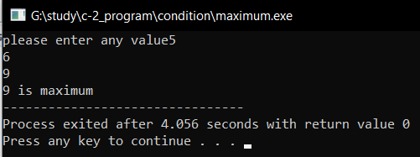

12. Write a C program to find out maximum from 4 numbers using nested if.

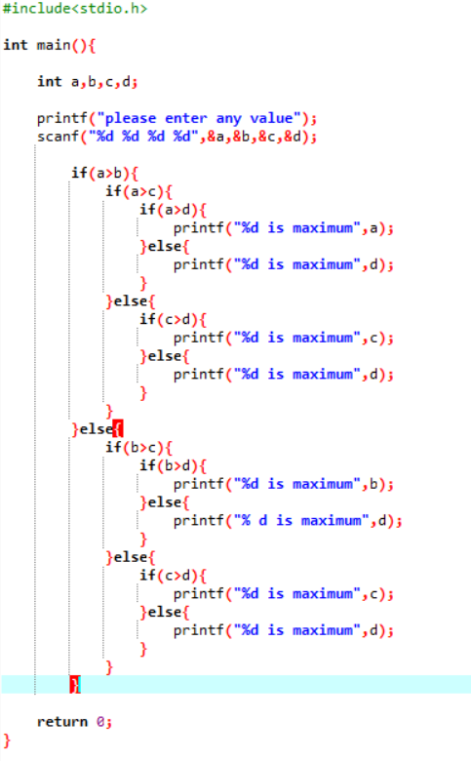

Output:-

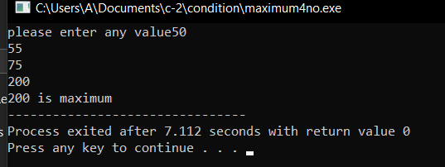

13. Write a C program to find out minimum from 4 numbers using nested if.

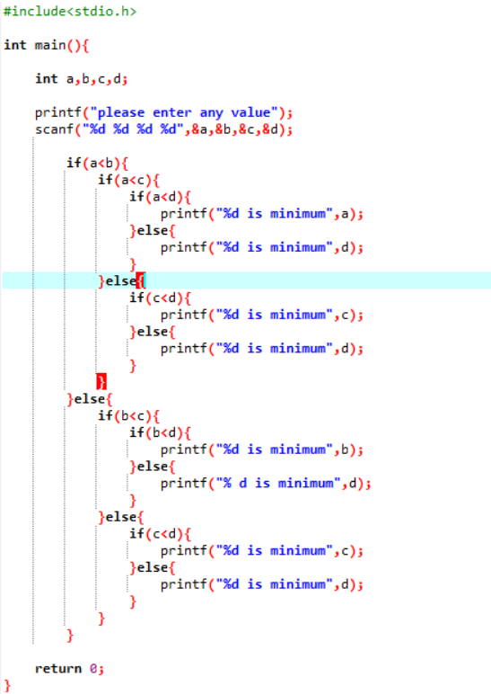

Output:-

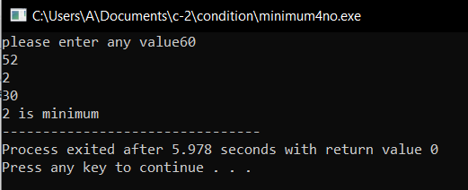

14. Write a C program to find user is eligible for blood donation or not using nested if.

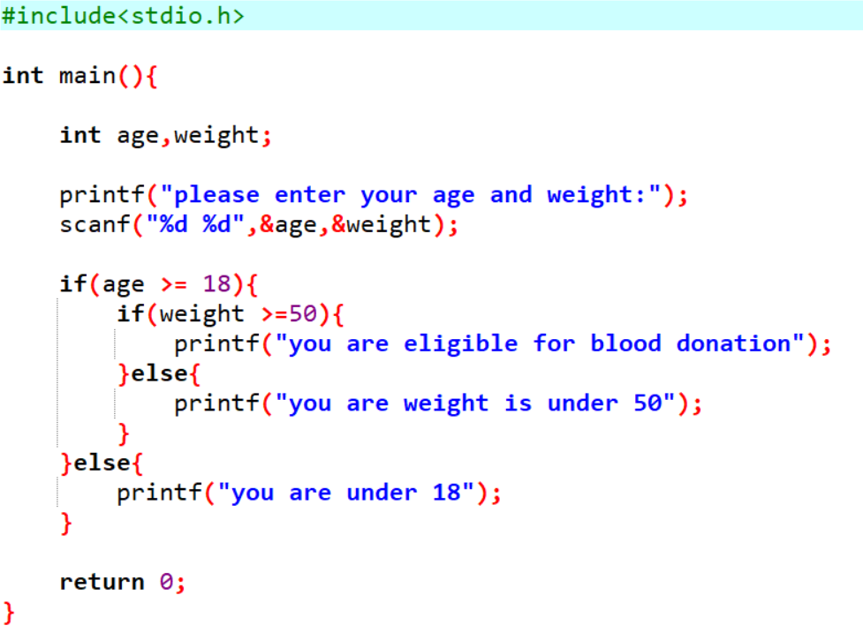

Output:-

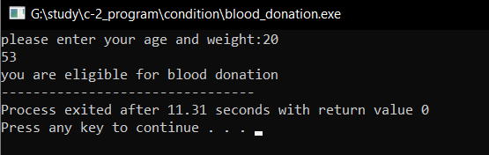

15. Write a C program to calculate sales discount from given image using nested if or (switch case and if condition).

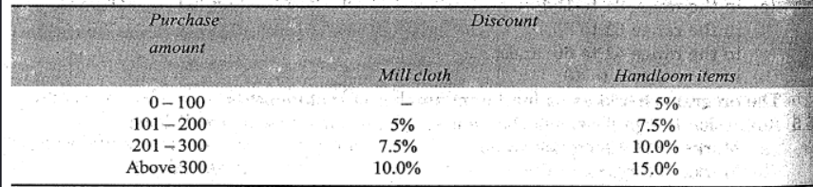

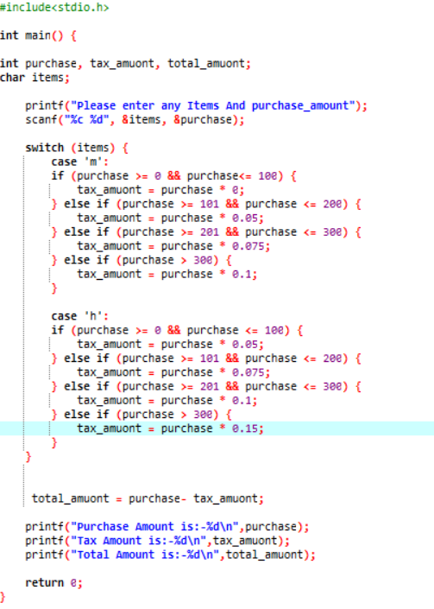

Output:-

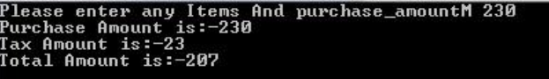

16. Reform 9th program using nested if.

17. Write a C program to find day name using switch case.

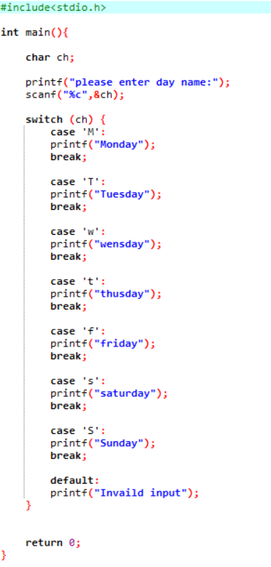

Output:-

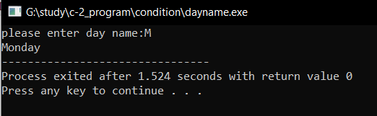

18. Write a C program to find month name from month number using switch case.

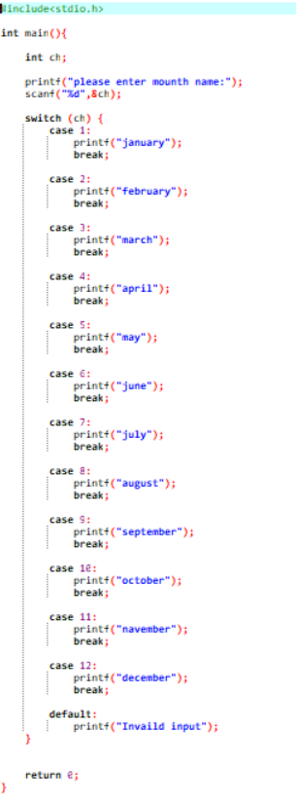

Output:-

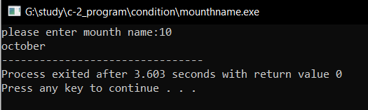

19. Reform 7th program using switch case and if condition.

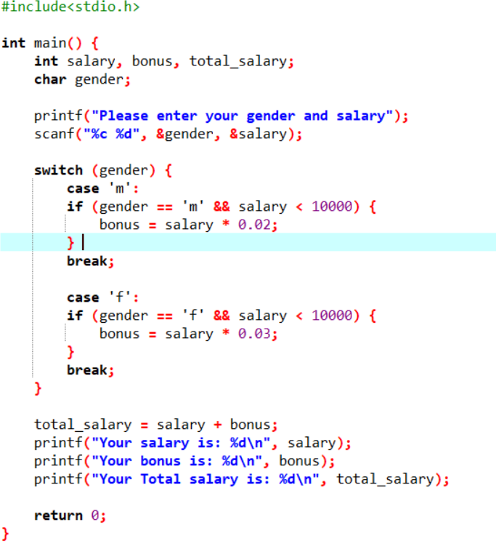

Output:-

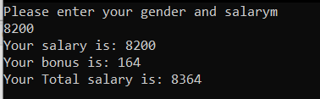

20. Write a program to check whether a given number is divisible by 5 or not.

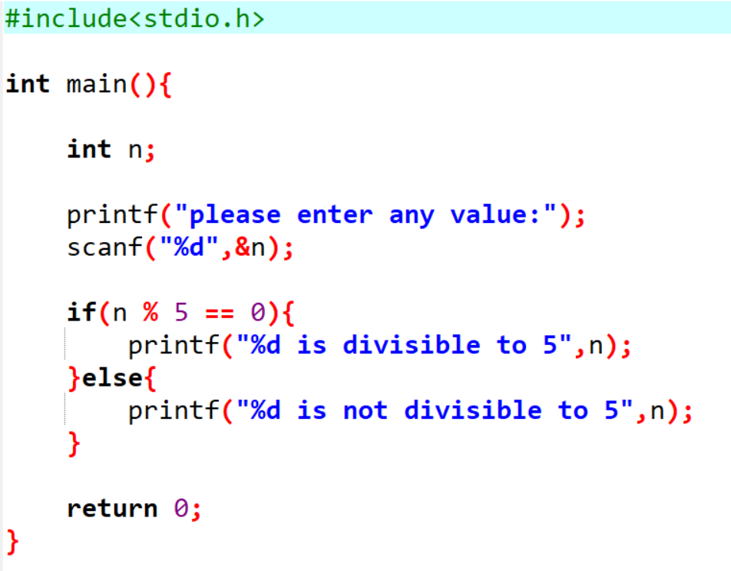

Output:-

